Cisco ME-3400

Guide for the ME-3400 L3 switch

Ruben van Osch

18-10-2021

Release

Contents

About 1

Setup 2

Resetting the switch 2

Requirements 2

How to 2

Uploading the default config 3

How to deal with that one student 4

The boot menu 4

# About

The Cisco ME-3400-24TS-A is a Layer 3 switch commonly used for connecting offices with other offices via [“Metro Ethernet” (ME)](https://en.wikipedia.org/wiki/Metro_Ethernet). In short Metro Ethernet is a dedicated ethernet line (Copper or fiber it doesn’t really matter) between for example a line between two company locations in the same “Metropolitan” area. The switch has 24 100 mb/s RJ-45 ports with 2 1 gb/s SFP (uplink) ports.

The Cisco ME-3400-24TS-A is different than your normal cisco L3 switches. All the 24   
RJ-45 ports are defaulted to UNI (User Network Interface) mode. This might cause some confusion if you do not know what it is. In short UNI isolates the connected device(s) from other UNI ports. The reason for this is because you wouldn’t want unauthorized access to different Metro Ethernet connections. More info [here](https://lifewithnetwork.blogspot.com/2016/03/cisco-switchport-type-uni-eni-nni.html).

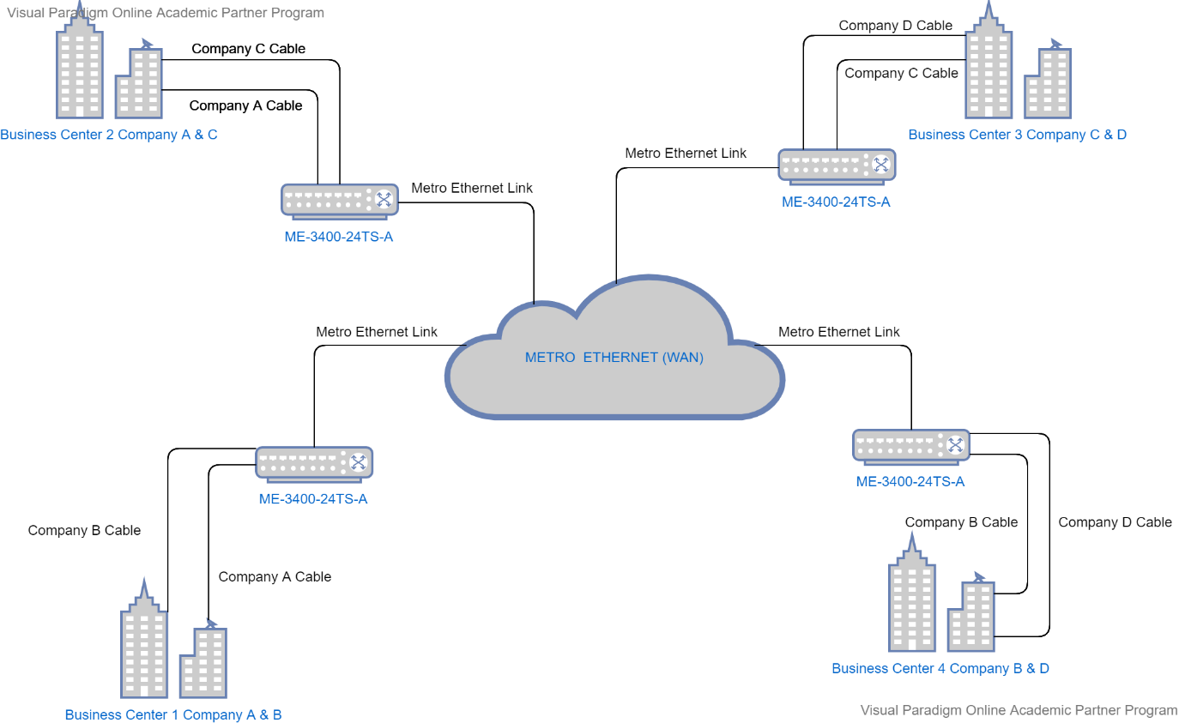

The picture above demonstrates a typical ME implementation. These ME-3400 switches just like the Metro Ethernet network are maintained by the ISP. You can also clearly see why by default ports are administratively disabled and are set on UNI mode. Cause what if an idiot enters the server room/closet and randomly plugs in a cable. He would have access to the Metro Ethernet which could cause potential damage if the port wasn’t automatically disabled. But enough of this Metro ethernet knowledge. Let’s look at how to actually set it up.

# Setup

If the switch configuration hasn’t been touched, you are good to go. Port 1 to 22 are for normal use. Port 23 and 24 are SPAN Ports. If this is not the case eighter ask the ISSD to reset, it for you or do it yourself.

NOTE: only do it yourself if you know what you are doing. This switch is not like your normal Cisco switch as stated above. I am not responsible for any physical/mental damage you or the ISSD may endure because of your actions. ITS ON YOU!

## Resetting the switch

### Requirements

* RJ-45 serial to USB (Or Serial port if you are old)
* Basic knowledge about Cisco CLI

### How to

First connect the RJ-45 to the console port and plug the USB in your laptop. Startup your favorite serial communication program, select the correct COM port, and use these settings:

* Baud rate: 9600
* Data bits: 8
* Stop bits: 1
* Parity: None
* Flow control: None

After this turn on the switch by plugging in the power. Look at the output until it stops spitting out stuff. When it states: “Press RETURN to get started!” you can press the enter key. If nothing was messed with it should look like below.

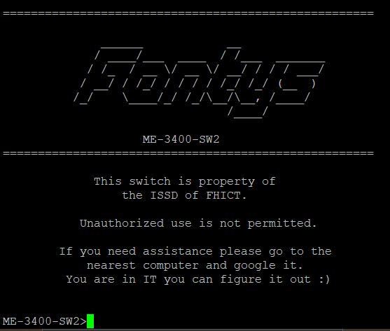

If there is a login prompt you should go to that… section.

Assuming you are in the system perform the following commands:

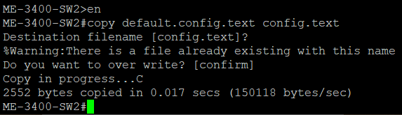

If the copy commands succeed all you need to do is reload the switch. Or you can copy it directly to the running-config and save it to the startup config.

If for any reason the “default.config.text” file is not present, you will have to upload it to the switch.

### Uploading the default config

You can get the file from my Git Repo [here](https://github.com/rubeste/cisco-me-3400-school-config) and download the “default.config.text” file. After doing this we will need to do a few things. First connect an ethernet cable from your PC to one of the ports. After doing this note the number on the port. For this tutorial we will assume you use the first RJ-45 port on the switch which is known in the switch as fa0/1. Use the following commands:

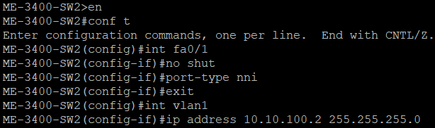

If the interface is not part of VLAN 1 change it via this command:

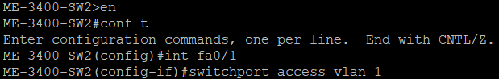

After this you will need to set your PC’s IP address within the 10.10.100.X/24 range.

After having done that we will need a tftp server. You can download one for windows [here](https://pjo2.github.io/tftpd64/).

Run the tftp server on the interface connected to the switch’s internet and select a folder with the downloaded “default.config.text” file. Use the copy command like this:



Fill in all the prompts with the correct information and you are done. You can now copy the “default.config.text” file to the “config.text” file.

### How to deal with that one student

Great so you are here to deal with a shitty student that set a password on the switch. What we will need to do is interrupt the normal boot sequence. To do this we will have to send a break operation via the console port during bootup. I had a lot of trouble with this so see if one of these will help:

Note: if the student was nice enough to disable password recovery it will do the deletion of the config.text & vlan.dat for you.

#### Normal method

Use the normal serial settings and try the following button combinations:

* CTRL + C
* CTRL + BREAK
  + Pause break that is
* CTRL + F6 + BREAK
  + If you are here, you probably should mash the buttons during bootup in random orders. That’s how I did it.

#### Sketchy method

There is a way to simulate the button that is absent on these Cisco switches. Though it is unreliable. To do this you will first have to shut down the switch and your serial console.

Restart the serial console with the following settings:

* Baud rate: 1200
* Data bits: 8
* Stop bits: 1
* Parity: None
* Flow control: None

Power on the switch and press and hold the spacebar for 10-15 seconds. After which you can close your serial console and connect with the normal settings. It this still doesn’t get you into boot mode you should probably try the button mashing strategy in the normal method.

### The boot menu

Now that you are in the boot menu initialize the flash by typing “flash_init”. After you done this remove the bad “config.text” and the “vlan.dat” file. After this you will need to copy the default.config.text file to the “config.text” file and reload. The switch should now load with the proper configuration.